Nayo customer portal
Nayo customer portal mainly has 3 main parts.
They are Customer portal, Supplier portal and admin portal.
Let’s start with the customer portal.
As you can see there are several sections under the Customer portal
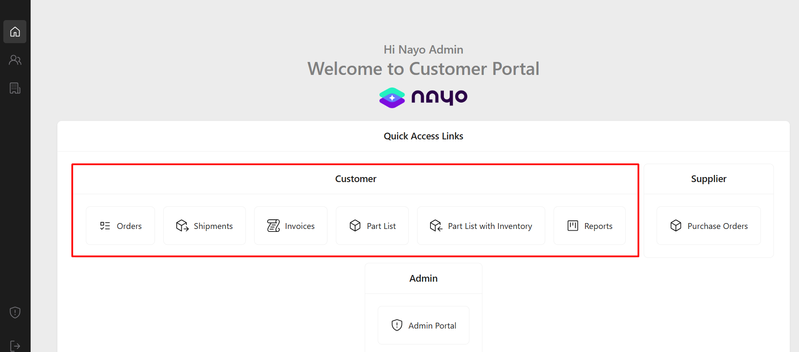
First it direct us to the customer orders (overview) page
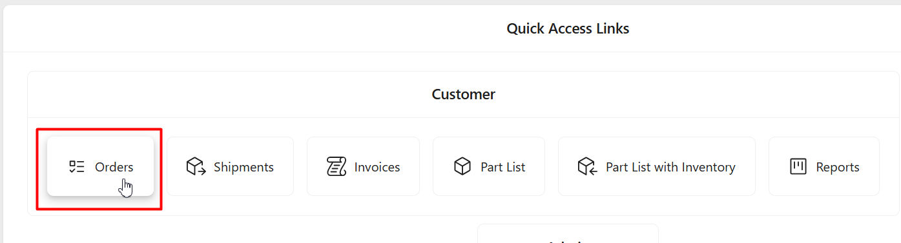
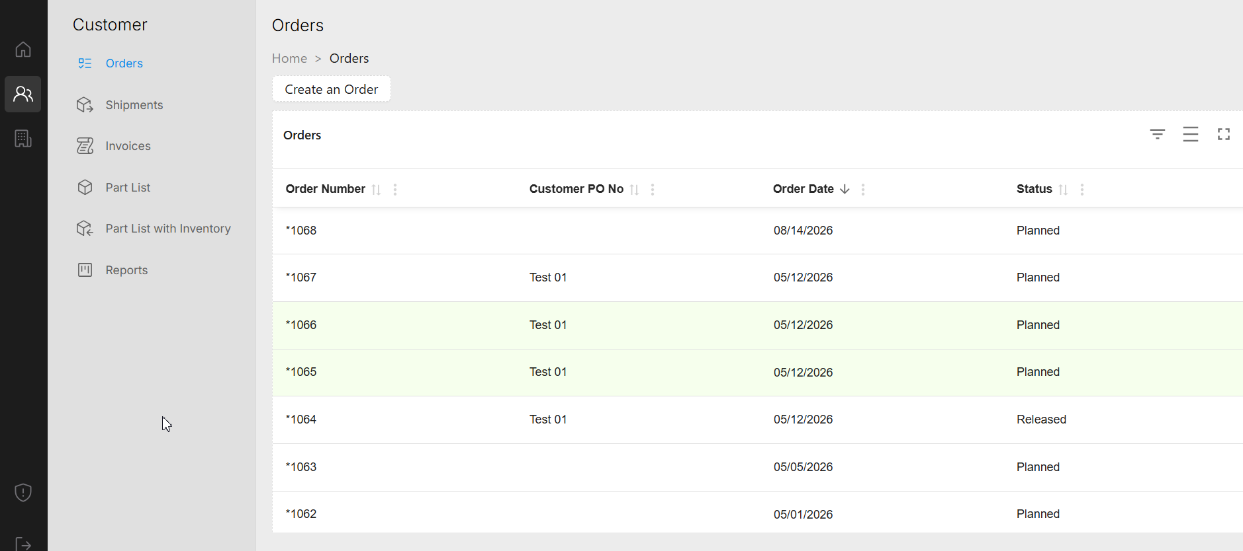
You can see the exiting customer orders with the status in the table view.
Customer order details can be filtered using this button in the right top corner.
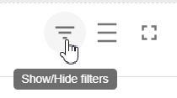
It provides the ability to search in each column.
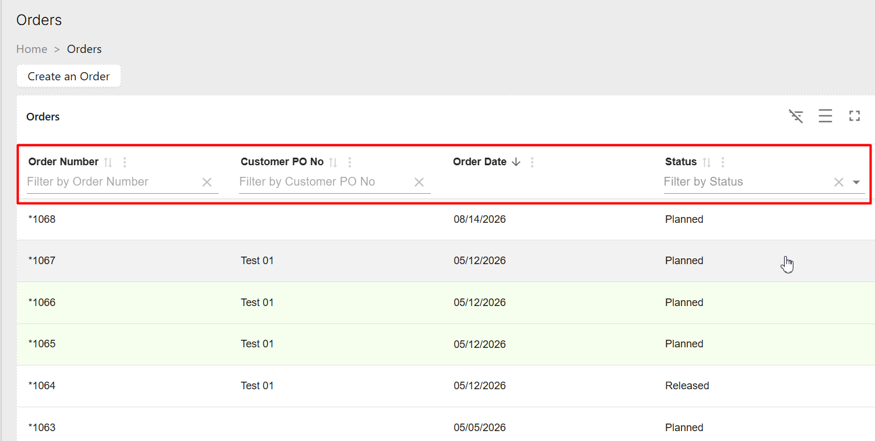
Also, the other two buttons can be used to adjust the toggle density and screen size.
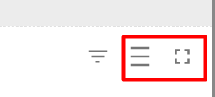
If you click on a customer order line, it will direct you to the detail view of the customer order.
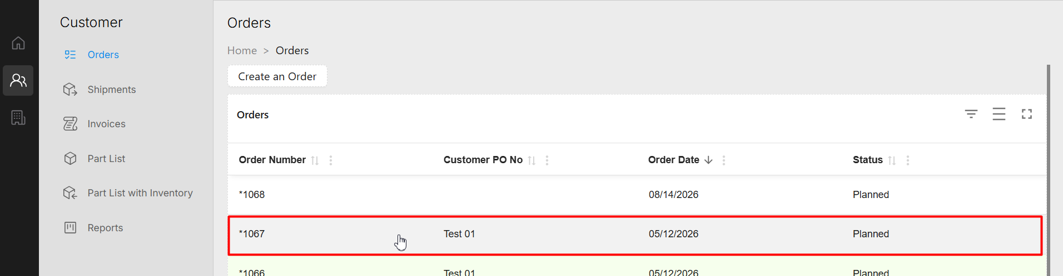
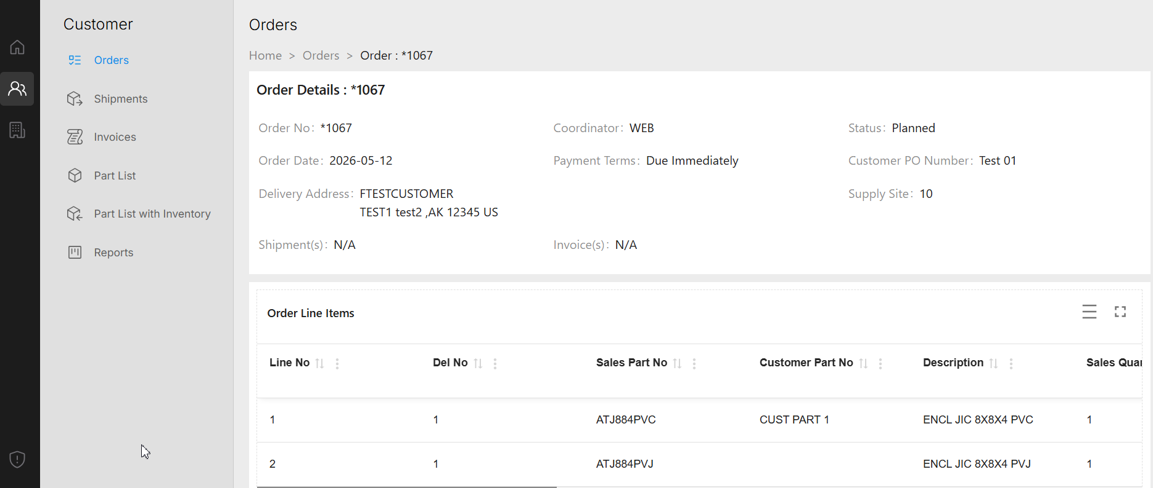
If you click on the customer order lines, it further direct you to the customer order line details.
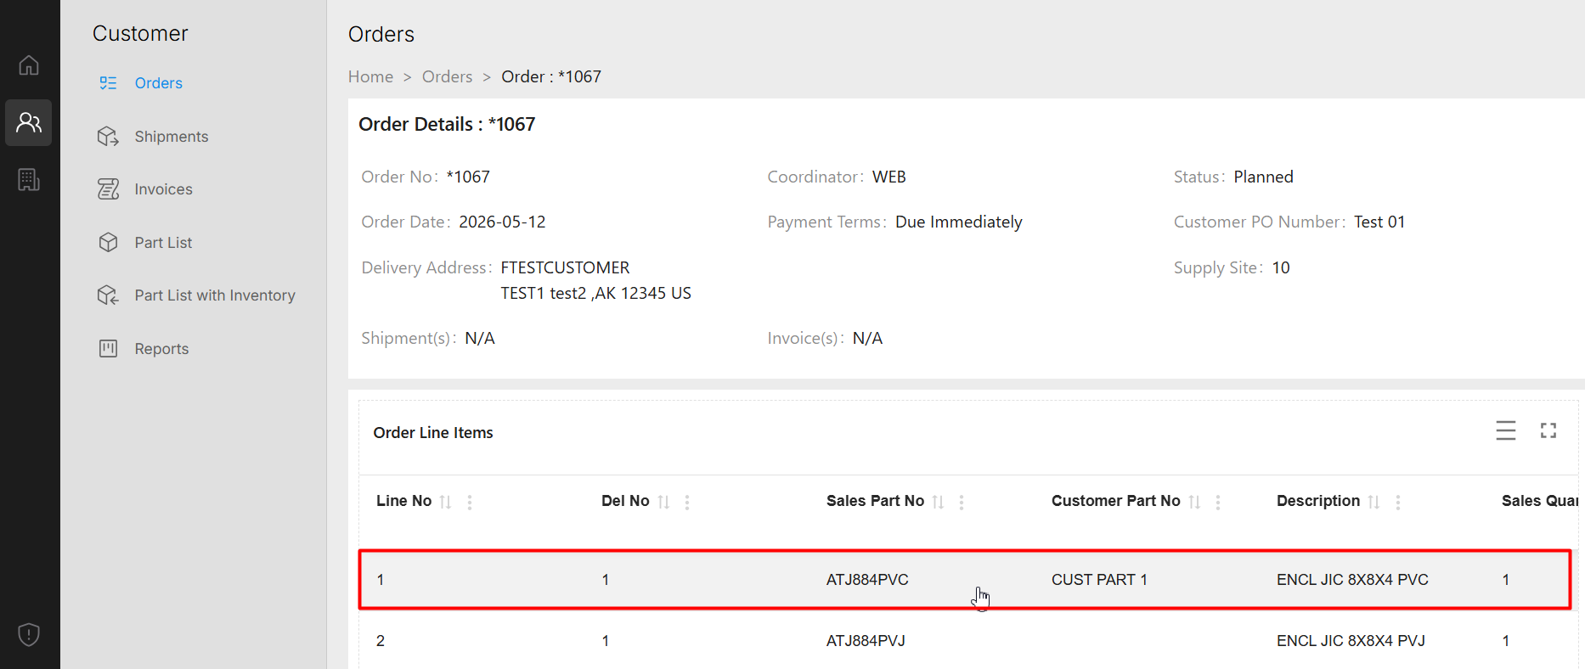
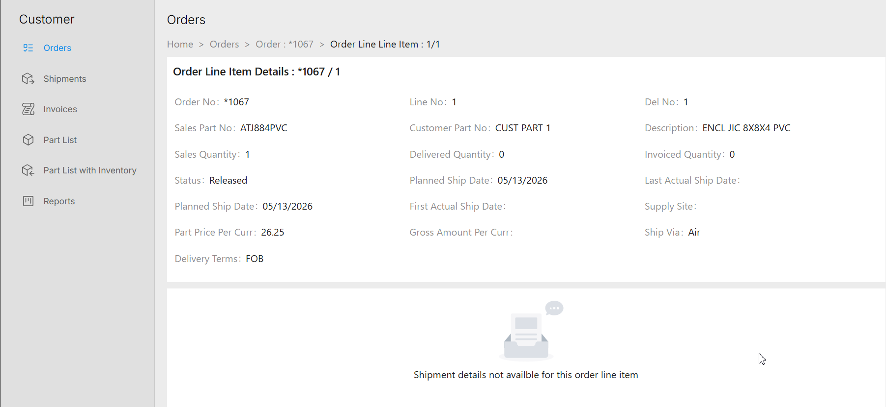
If there are any shipments connected on the customer order line, the shipment details are shown in the bottom part of the page.
let’s see one example of a customer order line which is connected to a shipment.
As you can see, the shipment details are shown on the same page.
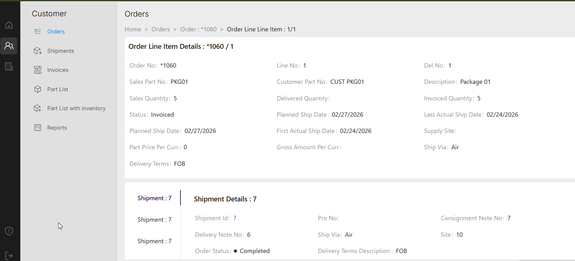
If we further scroll down in the same page, shipment lines tab and the Freight Transactions tabs can be seen.
Under the Freight Transactions Tab, the tracking information, weight, freight charges etc. information can be found.
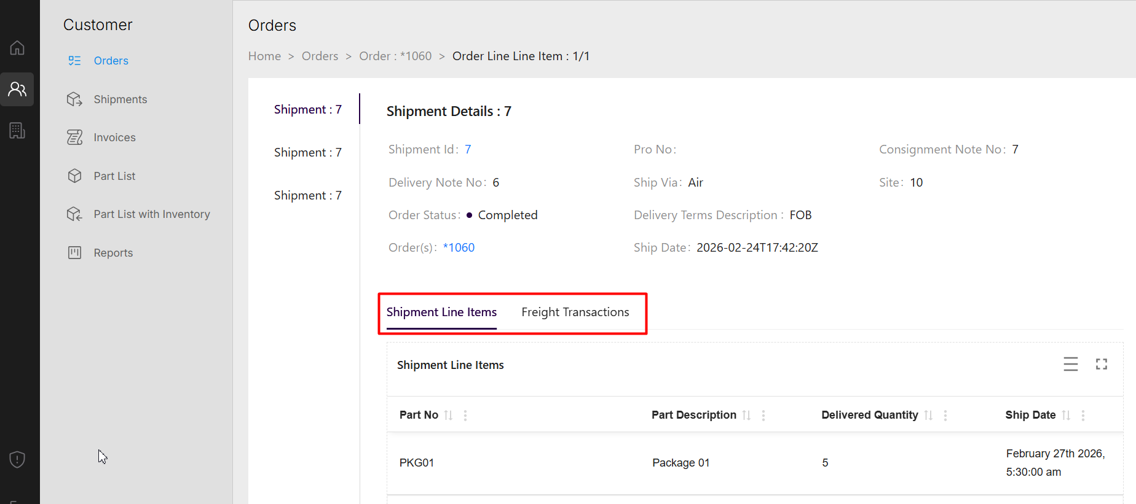
Create new customer order
Let’s see, how to create a new customer order using the portal.
If we go back to the orders section, at the top of the page we can find the icon “Create an Order”
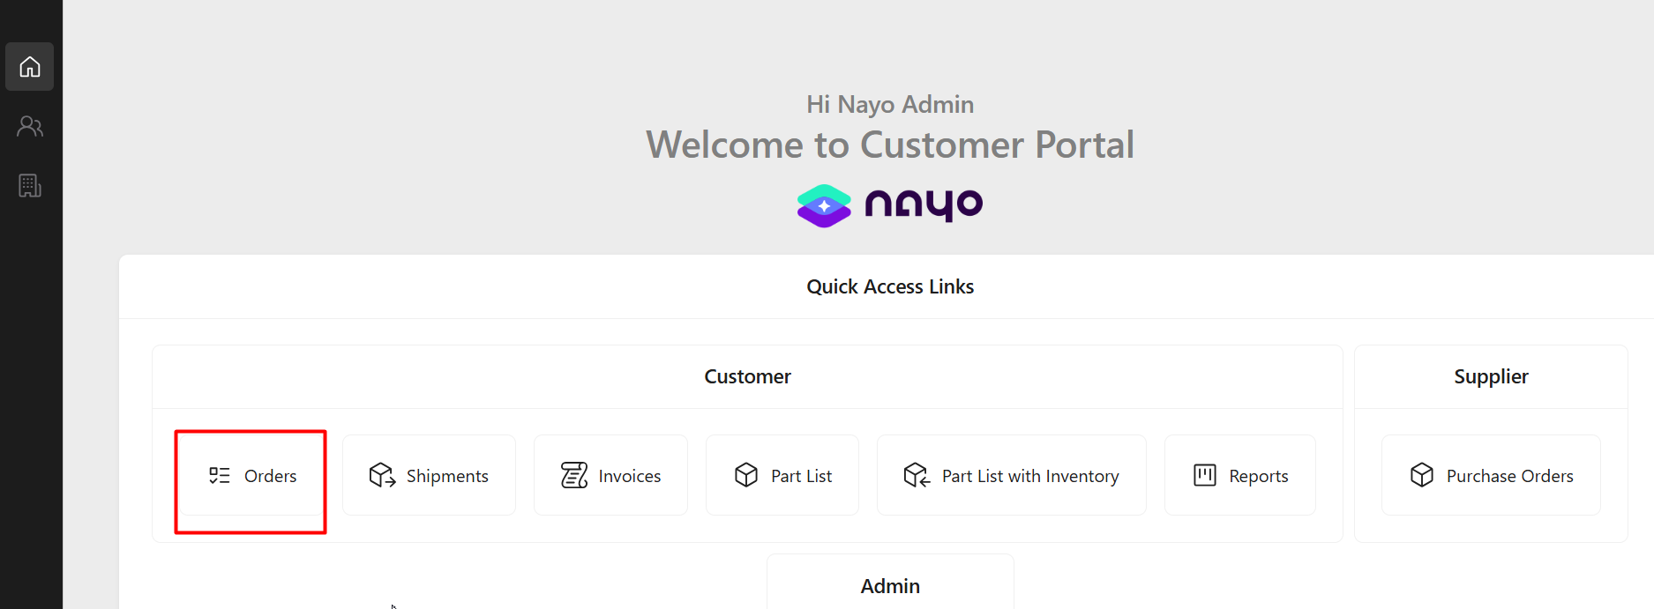
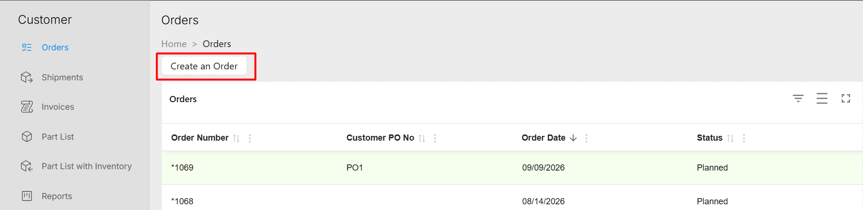
Once you click on the icon, it will direct you to the following page.
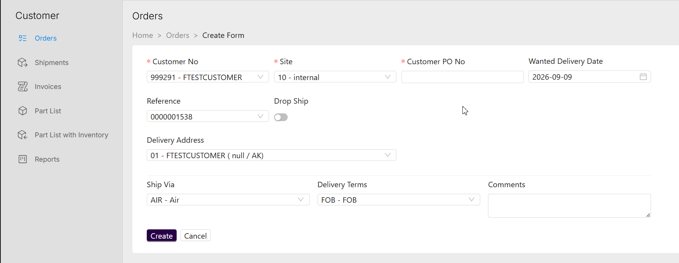
We can set the customer ID, Site, Customer’s PO No, Wanted Delivery Date etc. from the list of values and save the header details of the customer order.
Then you can add the customer order lines.
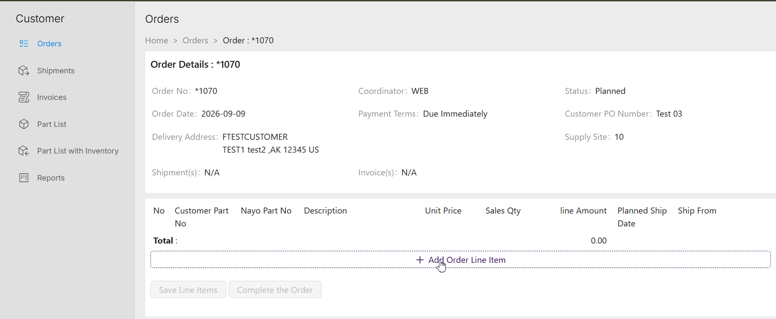
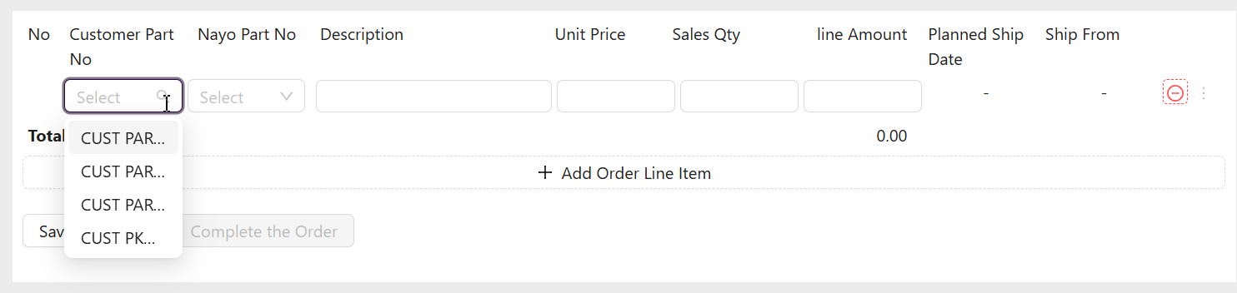

Once you add the customer order line details, the IFS generic part availability check logic can be run using the this option.
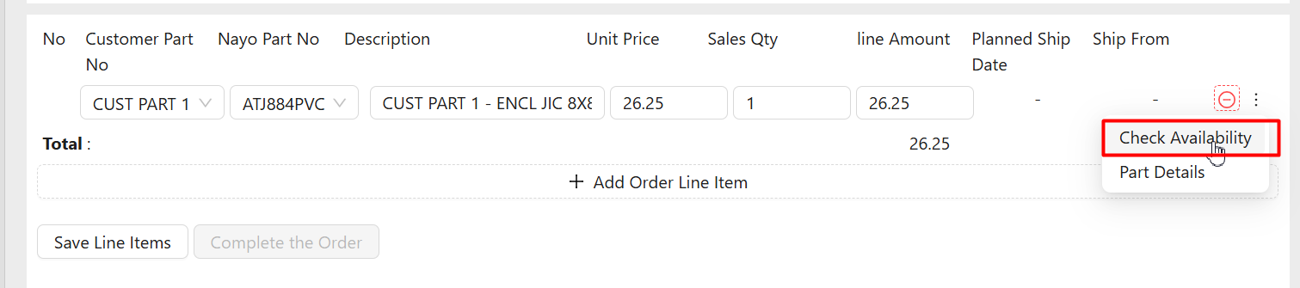
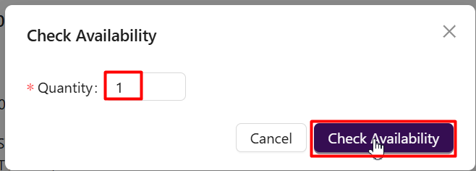
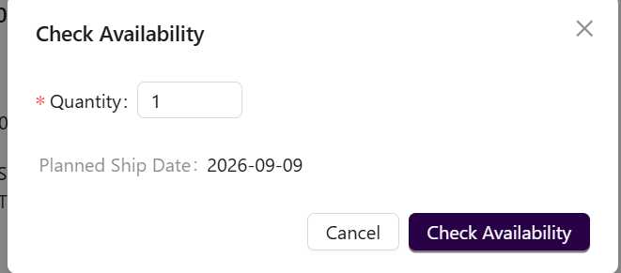
After adding all the customer order lines, you can save the line items.
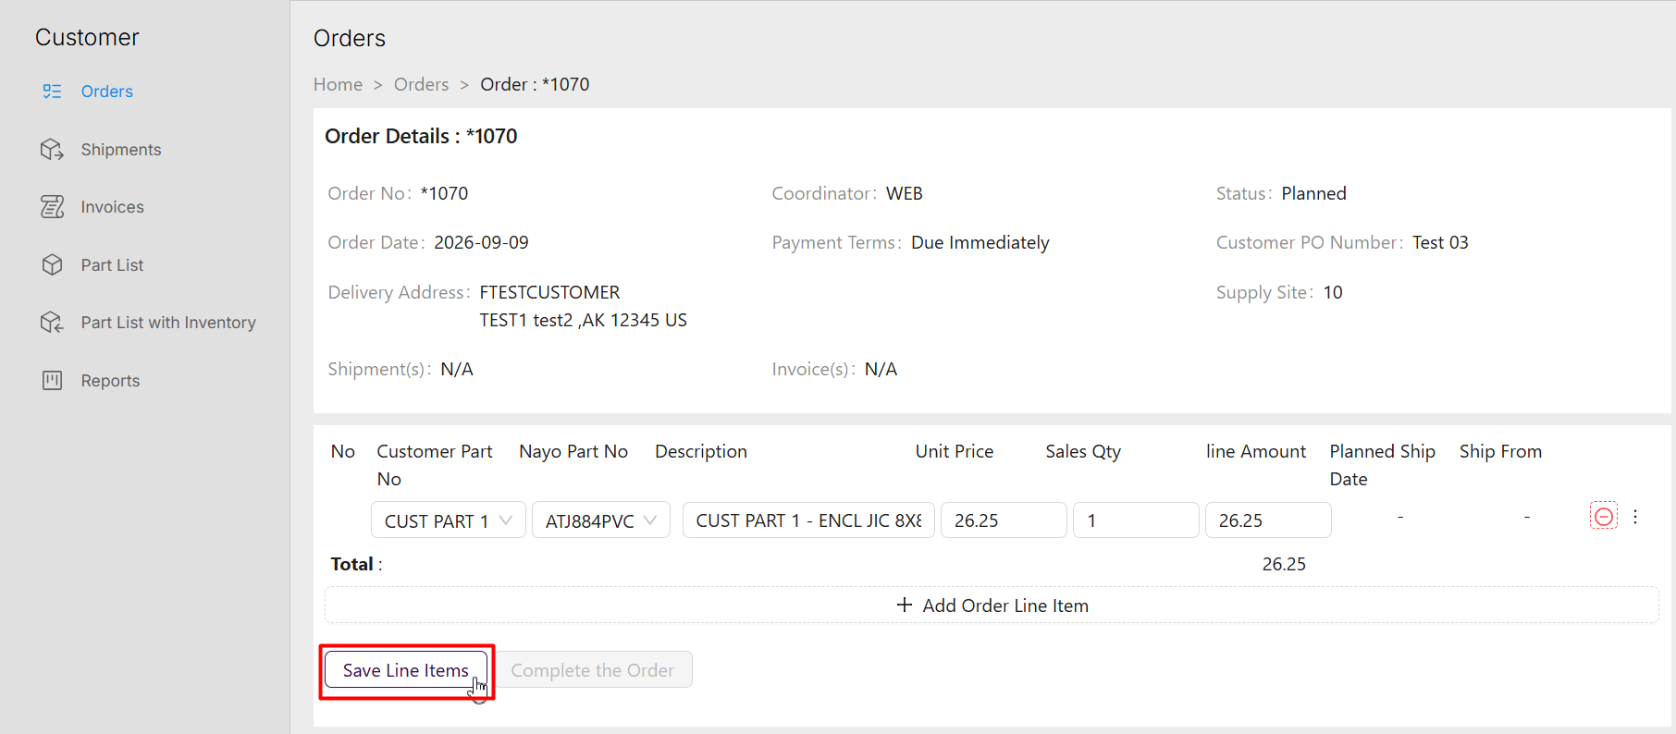
If we now look at the customer order created in IFS side, we can identify the orders created through the portal as those has the Order type “WEB”. Also, until we complete entering the order in the Nayo portal side, the custom filed “cf web order status” takes the value “Entry in progress” and later it is changed to “”Completed”
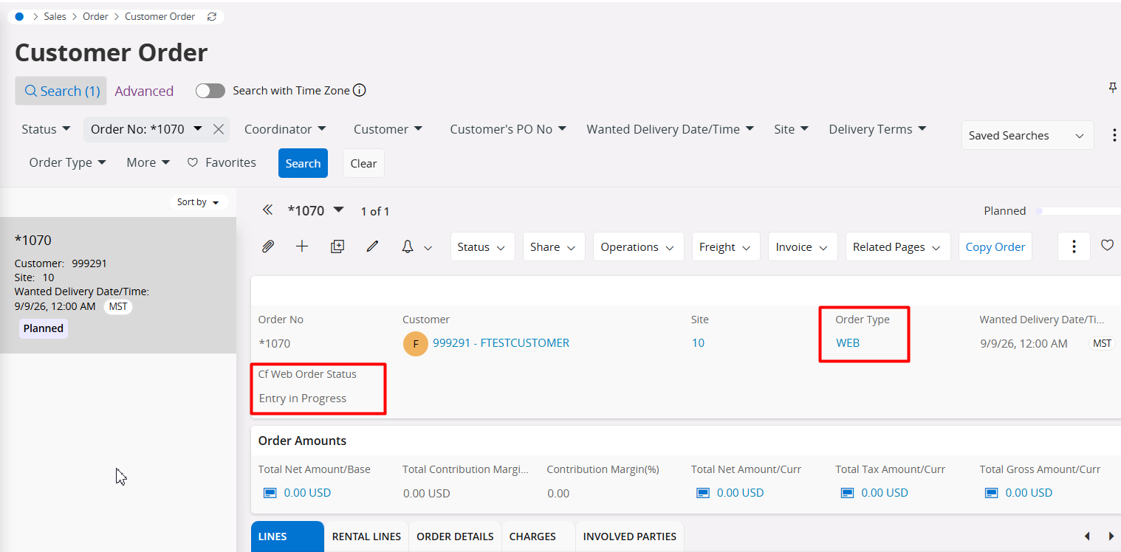

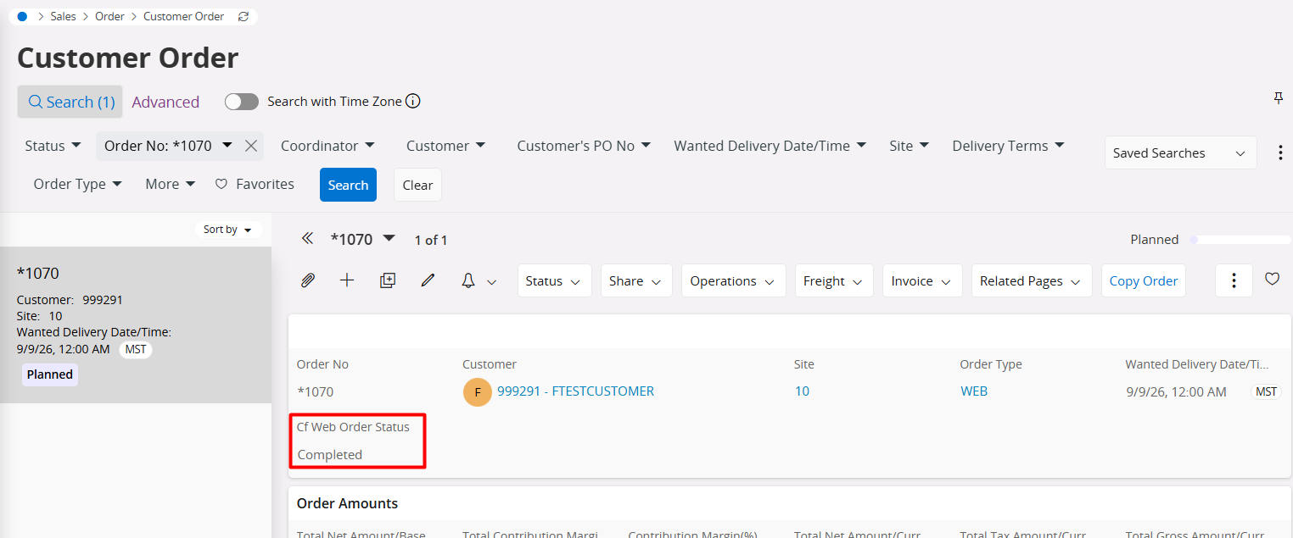

Shipments
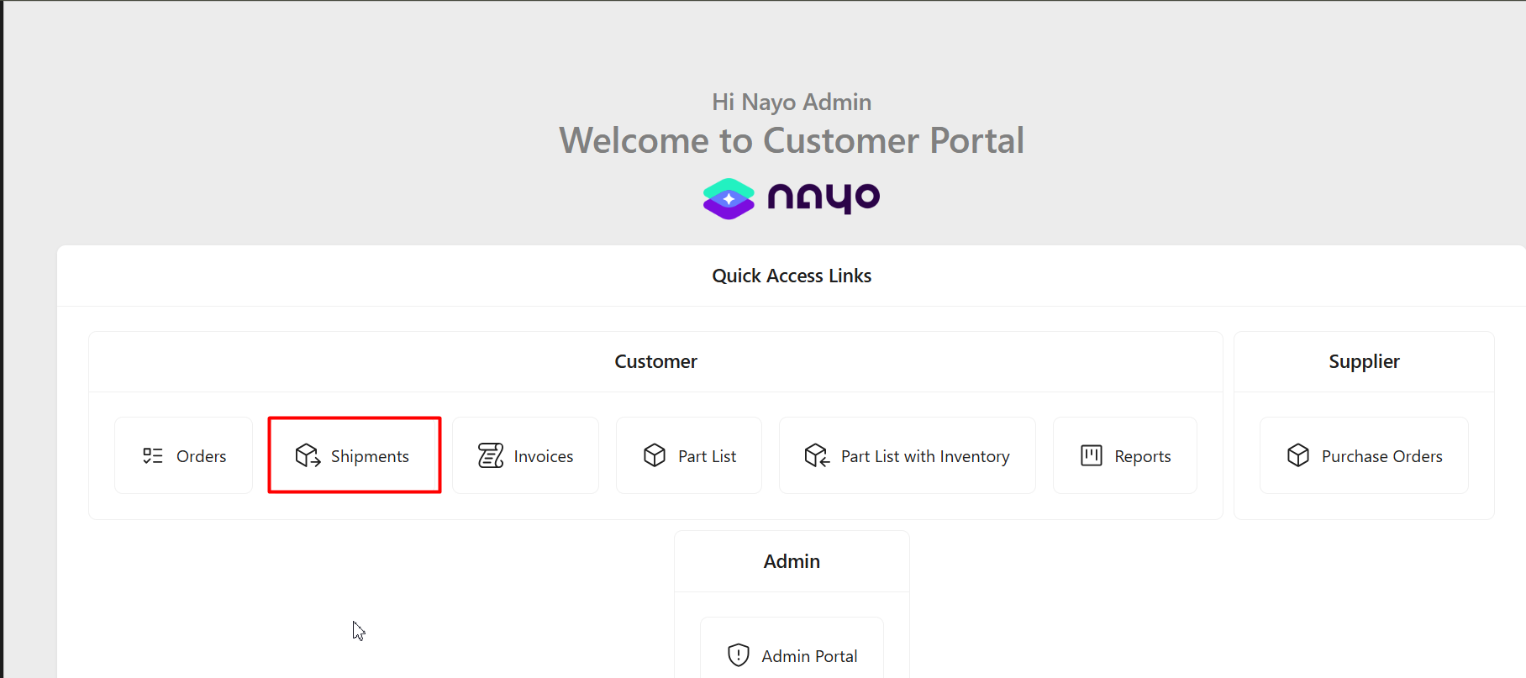
Created shipments can be directly accessed via the Shipments section.
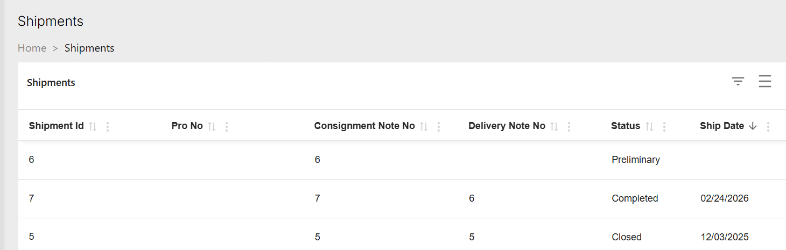
By clicking on a specific shipment, you can go to the detailed view of the shipment. We discussed this earlier as well.
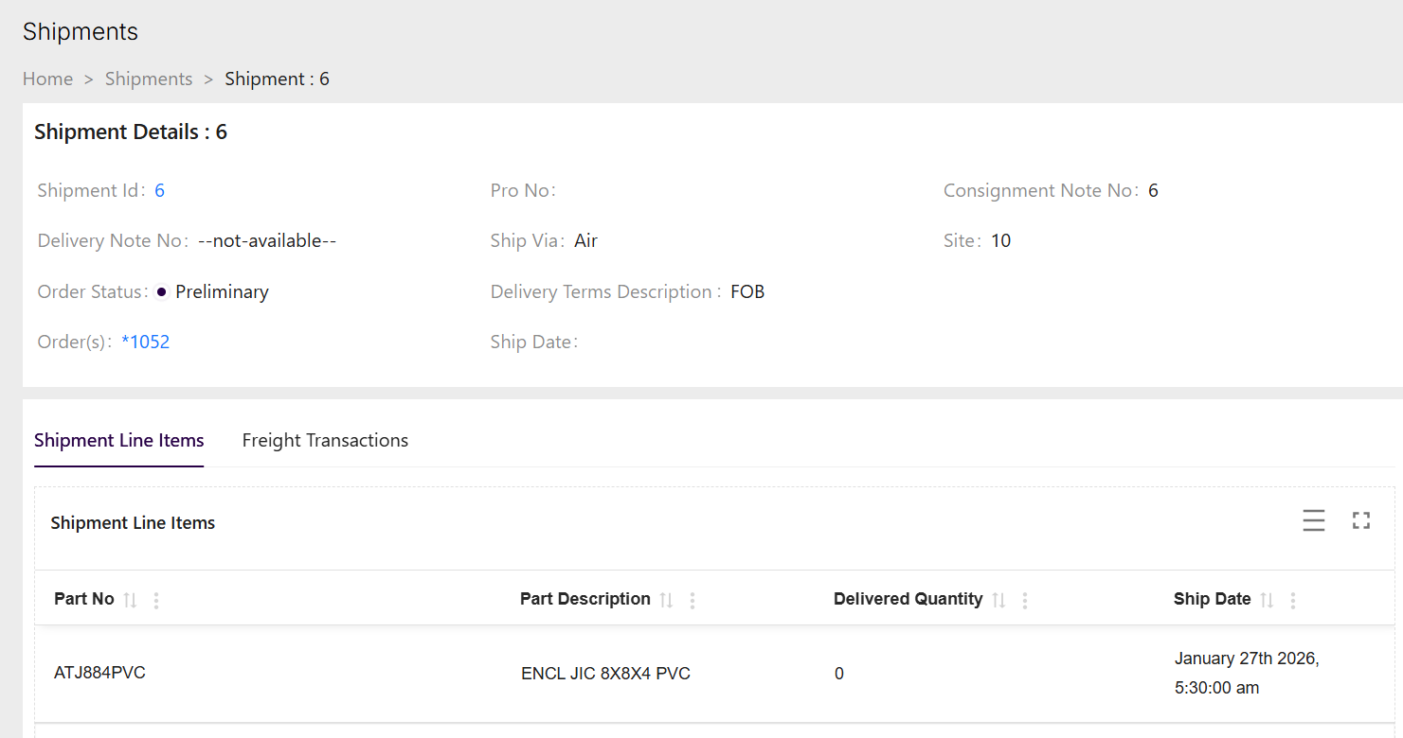

Invoices
The customer invoices created in IFS side can be viewed under this section.
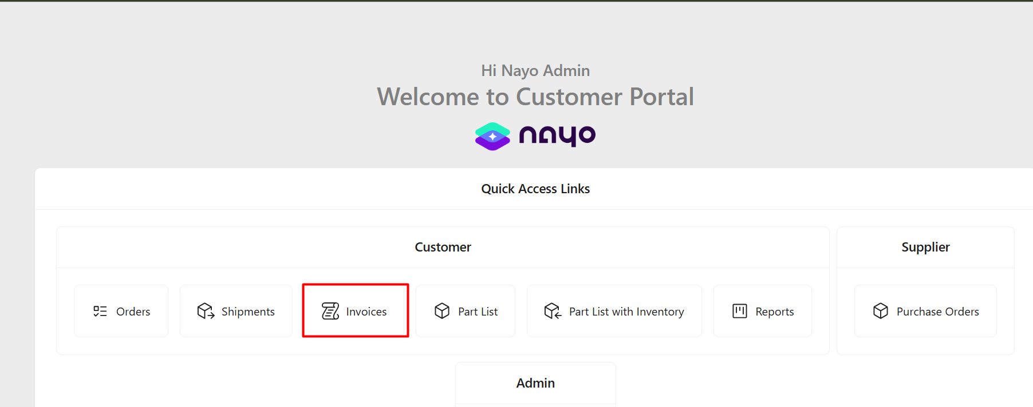
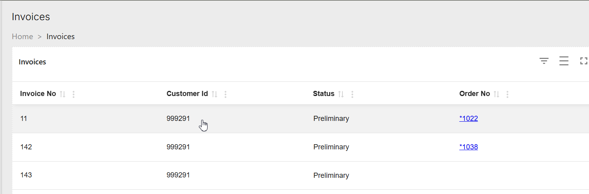
If you click on a specific invoice, it will show the detailed view of the customer invoice.
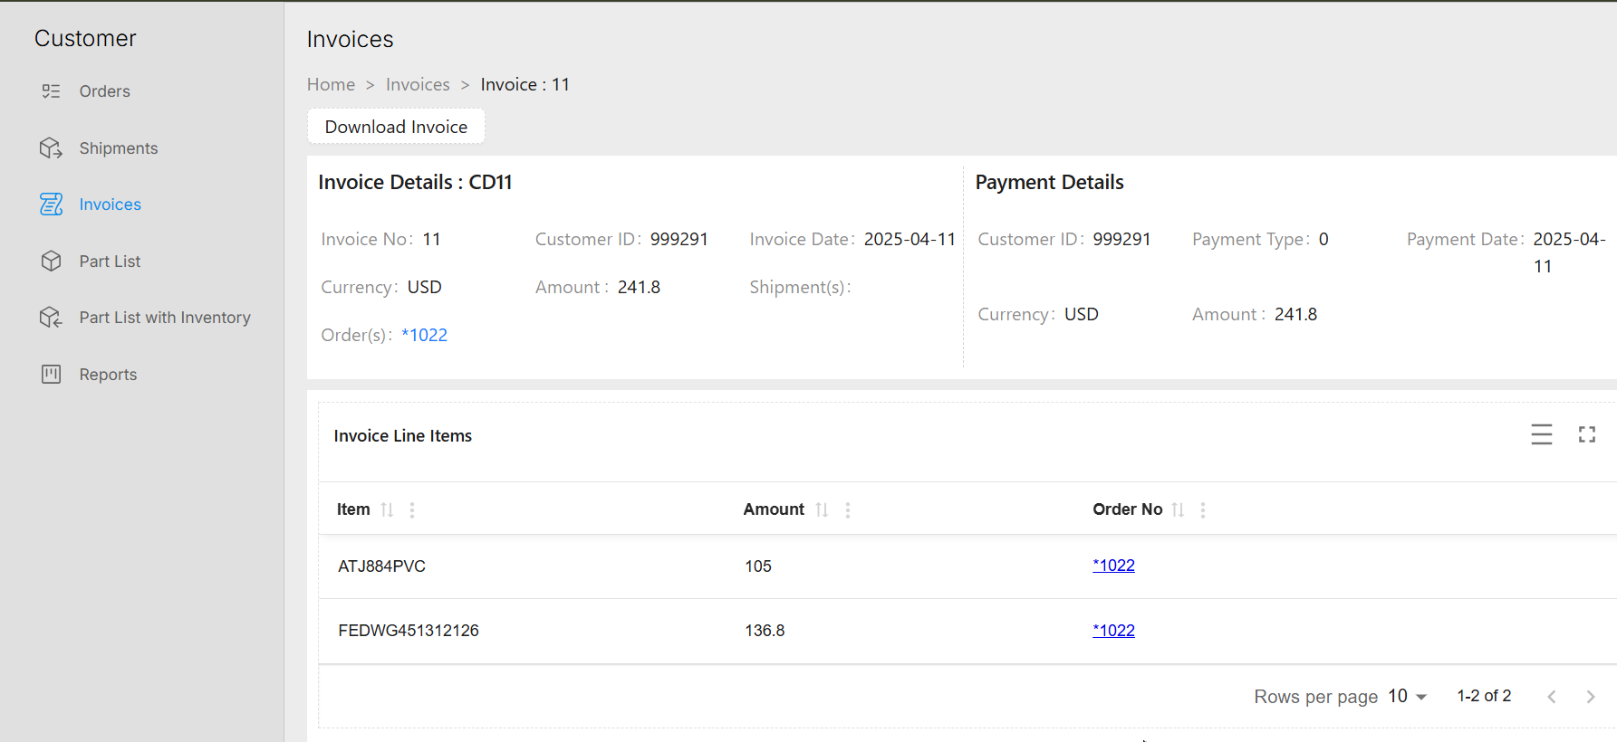
Also, the Nayo portal has given the option to download the invoice from the customer portal using this “Download invoice” button.
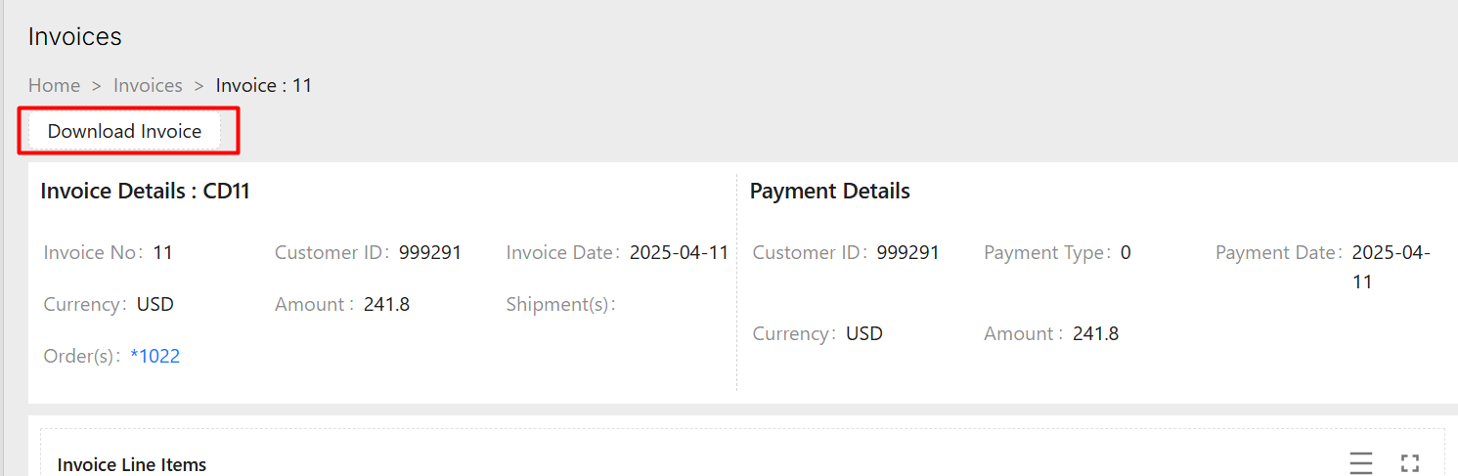
This is the print preview of the customer invoice.
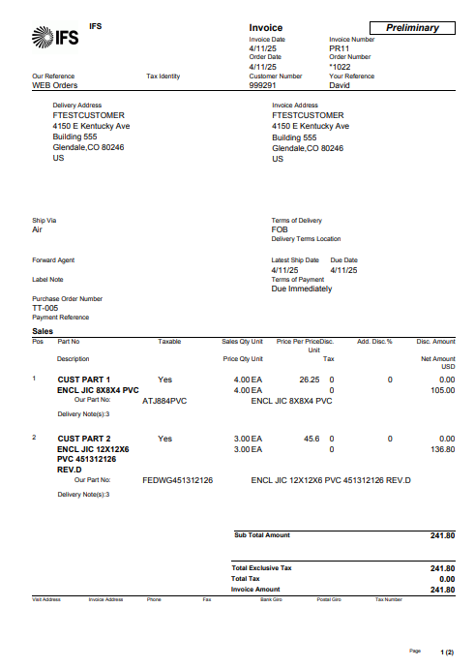

Part list
In this section of the Nayo portal, the sales parts connected with the customer retrieved from the IFS customer agreements, sales price lists and other IFS pricing logics.
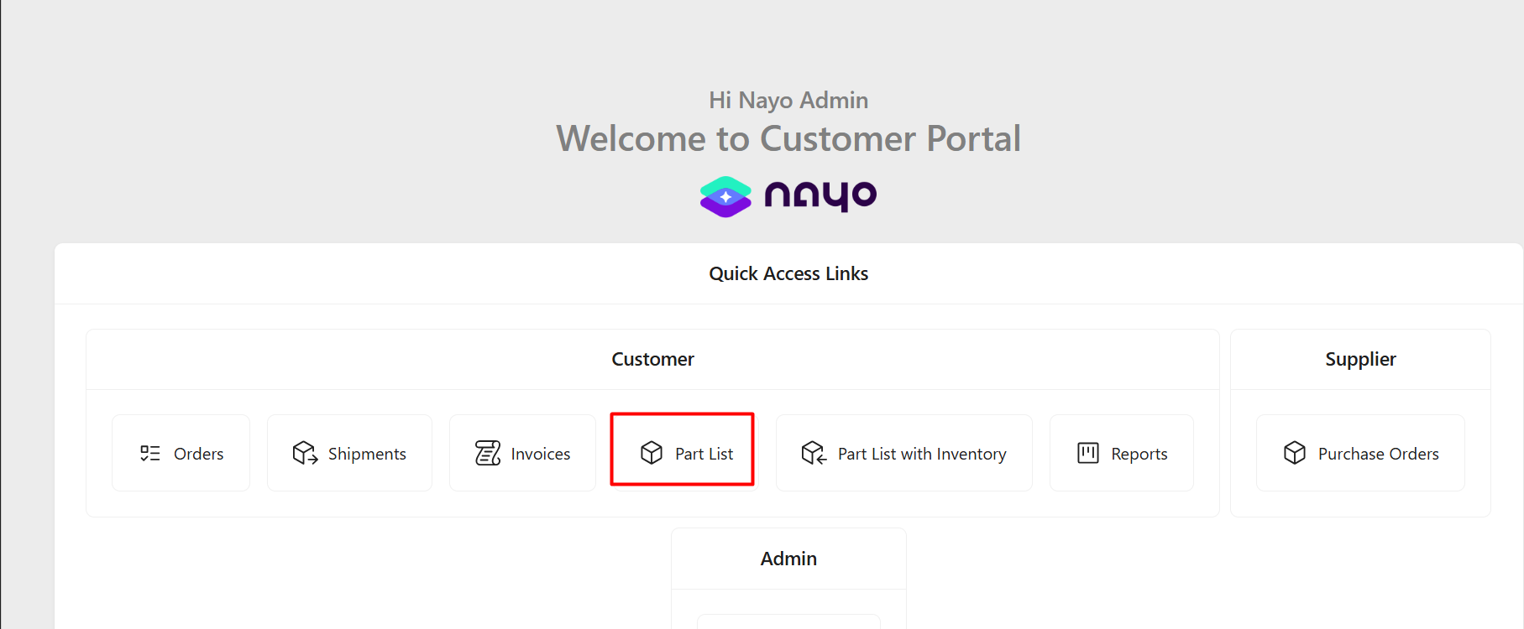
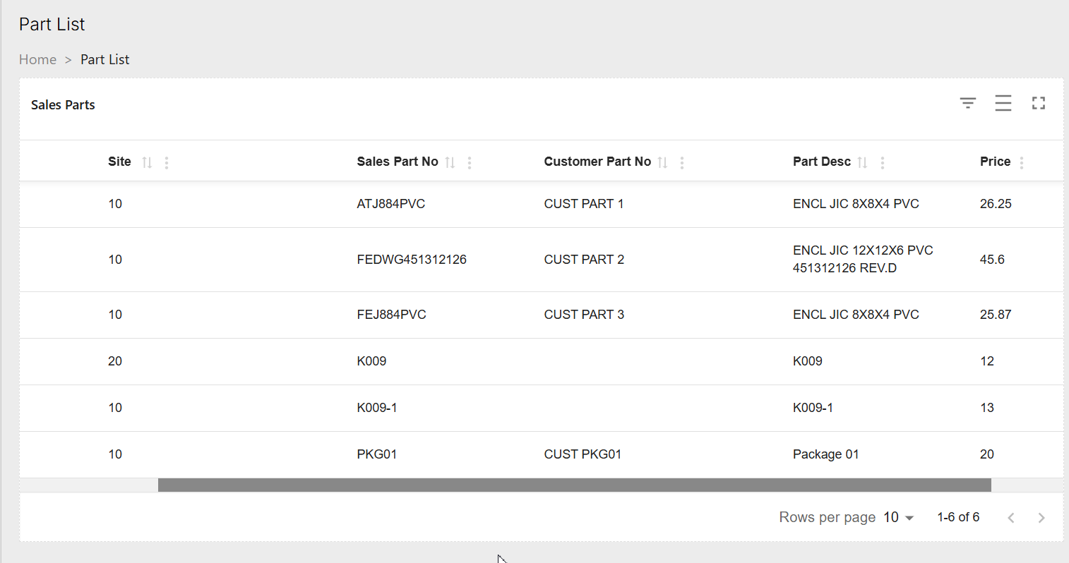

Part list with Inventory
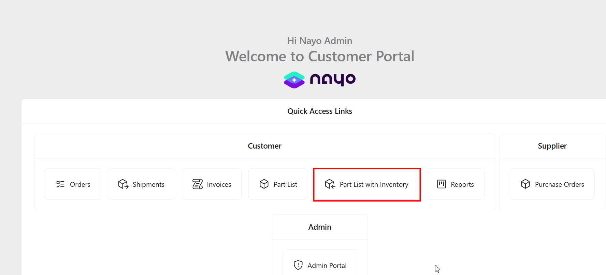
Under this section, we have given the visibility of the IFS inventory levels to the portal users.
If we go to the detailed view, the Available inventory part Quantities per site wise can be observed before placing a new customer order.
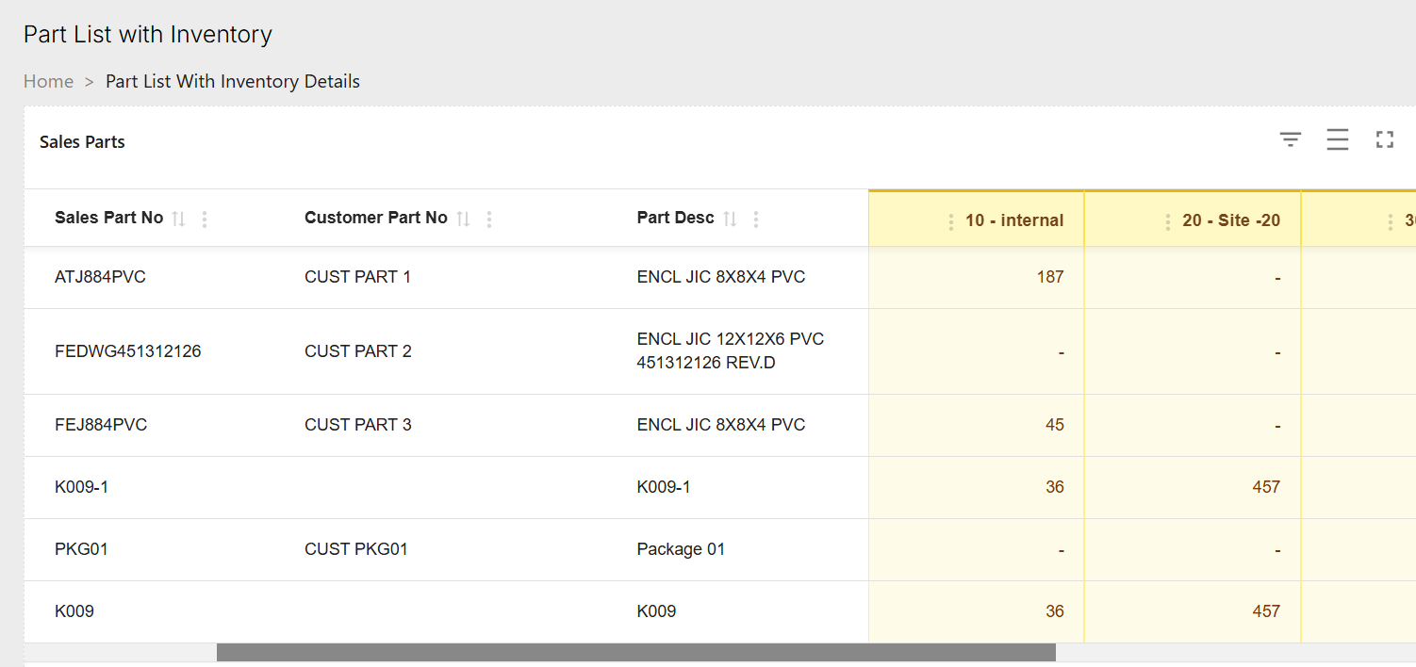

Reports
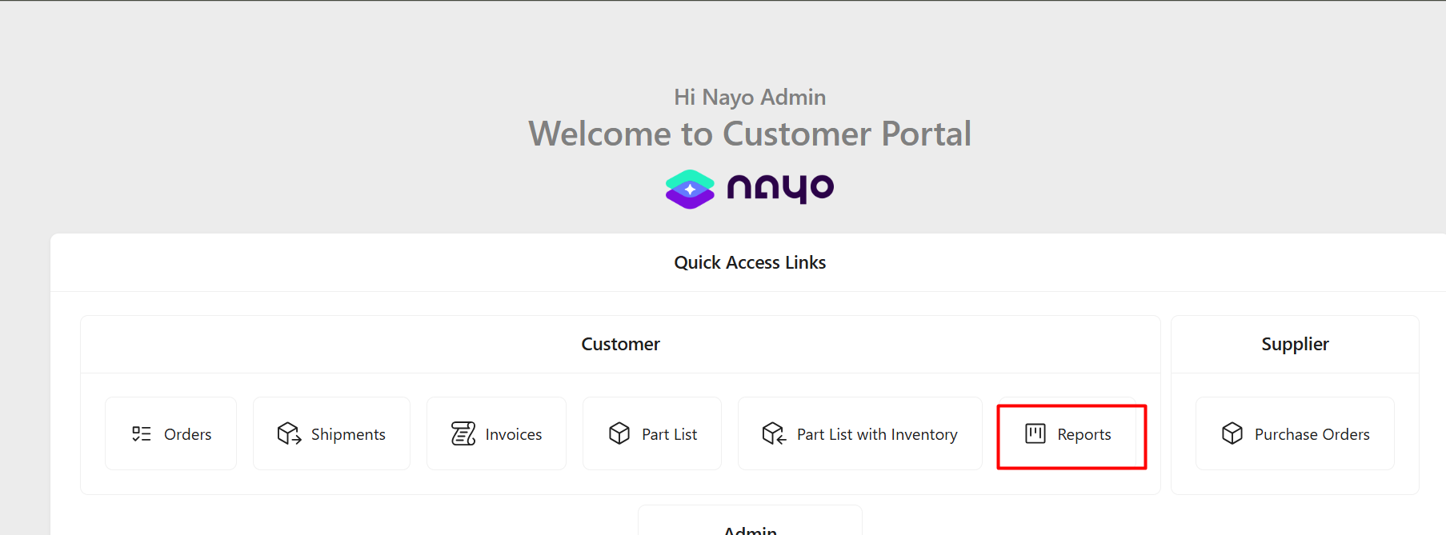
This section of the customer portal is to print and preview some of the IFS reports. In this example, the customer statement of account report and Price list report is there to download. This can be customized to accommodate the customer report requirements.
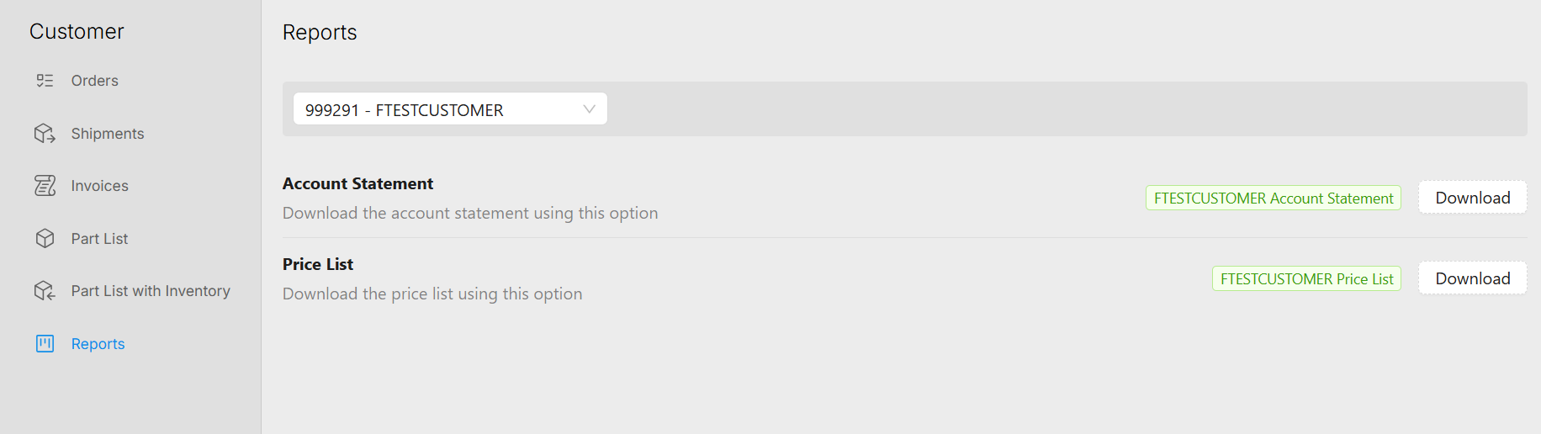

Supplier portal
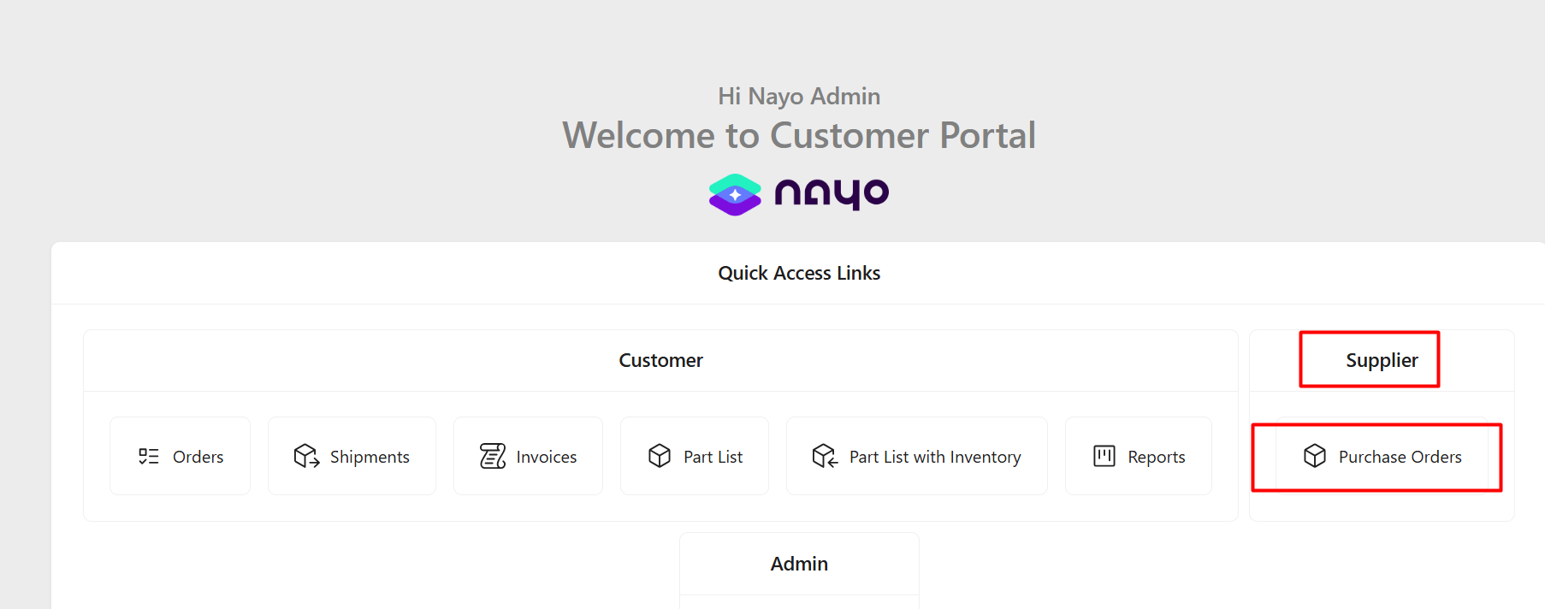
There is a separate section in the portal to handled the supplier orders. The Purchase orders section, provides the visibility to the purchase orders created in IFS side. Suppliers who use the Nayo portal can view the purchase orders created in IFS for them.
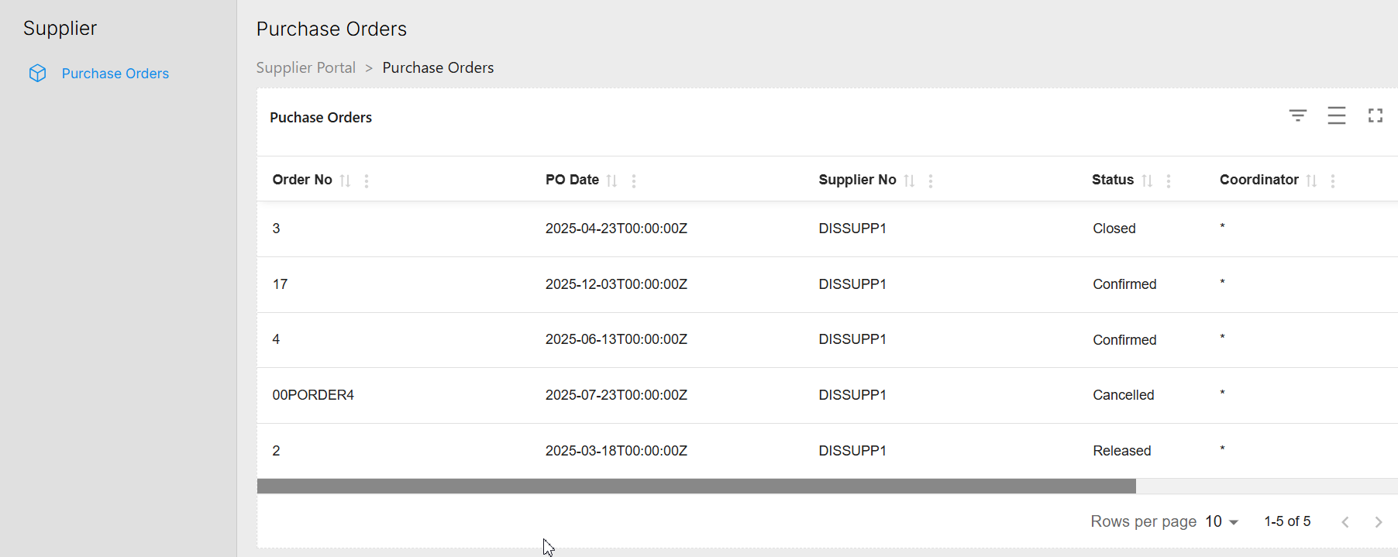
In the detailed view it shows the Purchase order header level information and part and no part order line information.
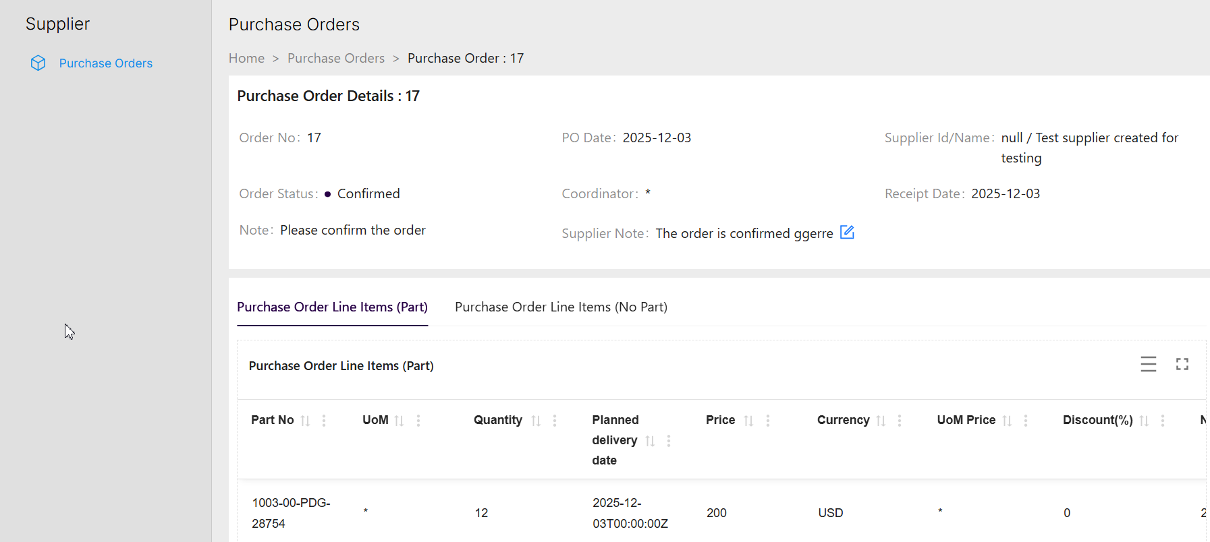

The supplier note can be added and edited from both Nayo portal and IFS end which can be currently used as a communication method between IFS and Nayo portal in purchase order process.
